I think I profoundly want peace and continued contentment.
As someone who struggles with anxiety and depression, I am in a state of being content right now. I feel that I am in a safe place in regards to my relationship and friendships. The obstacle would be change. The future waits for no one. As things change, I fear the peace not lasting and losing myself again. I think that through the talisman I would want to include a menagerie of the good things I have now as I want to hold onto them. I also have had the thought of running away from the darkness and this black void of depression and panic attacks. I think there is a contrast between the dark and the light. When I picture the things that I love I see blues, yellows, oranges, flowers, animals, globs of paint, and I would like to incorporate things to represent my friends, boyfriend, and family. I think playing with color would really add to the contrasting emotions I want to express.
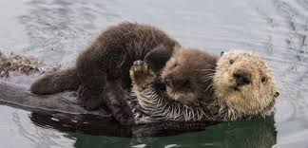
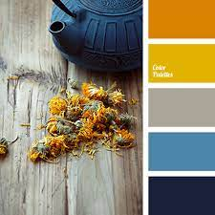
Peace and light in the present avoiding the dark future.
